

Guide to Becoming a Trustee

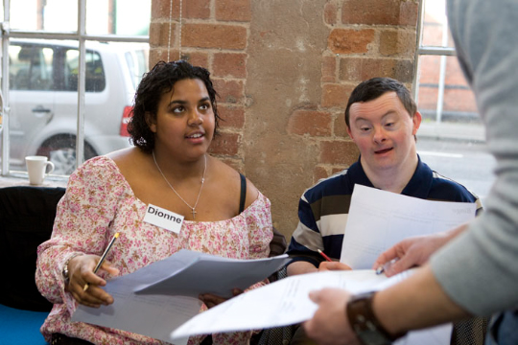 | What is a Trustee?  - OHT is a charity  - A trustee helps to run the charity but they do not get paid.  - Each charity has a few trustees  - A group of trustees together is called a Board  - They meet together to talk about what the charity is doing.  - They check that the charity is doing OK.
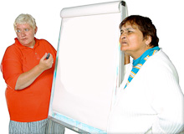 | What a Trustee does?  - Trustees must make sure that OHT follows the law.  - Trustees must make sure that OHT does what is says it’s going to do.  - Trustees help with looking after OHT’s money  - Trustees help with looking after people who work for OHT  - Trustees help decide what OHT will do in the future.
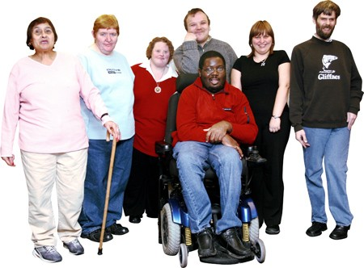 | Becoming a Trustee  - You must be over 18.  - You must be able to sort out your own business, like bills.  - You must be honest.  - Another Trustee has to ask you to join.  - You must work together with other Trustees.  Some trustees have special jobs on the Board like Chairperson or Treasurer.  OHT trustees meet once every three months.  Each meeting lasts for 2 hours
Opportunity Housing Trust  Board of Trustees Handbook | A Separate booked called the Board of Trustees Handbook can give you more information
    @ | If you want a copy of the handbook or if you want to talk to someone about becoming a trustee, please call Mandy Evans, Chief Executive, OHT  02920 236216  mandye@oht.org.uk

